Nginx Deployment Lab Manual - Two Approaches
This lab teaches two methods of deploying a simple website using Nginx.
Approach 1: Use the official Nginx Docker image.
Approach 2: Install Nginx manually inside an Ubuntu Linux container.
Each exercise contains:
• Objective
• Command
• Explanation
• Expected Output
• Screenshot Placeholder

Approach 1 - Pull Nginx Image
Command:
docker pull nginx
Explanation:
Downloads the official Nginx image from Docker Hub.
Expected Output:
________________________________________
Screenshot Placeholder
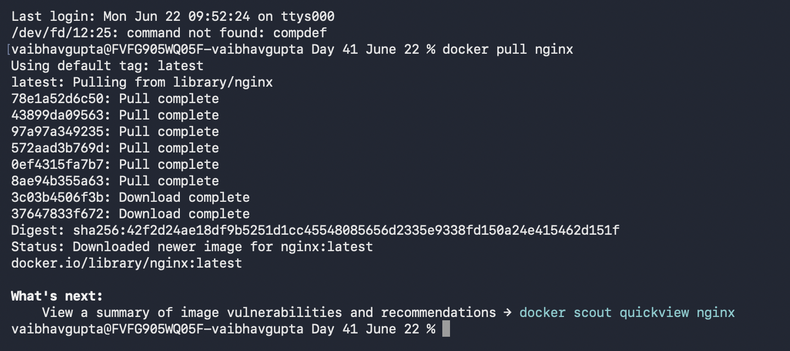

Approach 1 - Run Nginx Container
Command:
docker run -d --name myweb -p 8080:80 nginx
Explanation:
Starts an Nginx container and maps port 8080 on the host to port 80 inside the container.
Expected Output:
________________________________________
Screenshot Placeholder

Approach 1 - Verify Running Container
Command:
docker ps
Explanation:
Displays running containers.
Expected Output:
________________________________________
Screenshot Placeholder
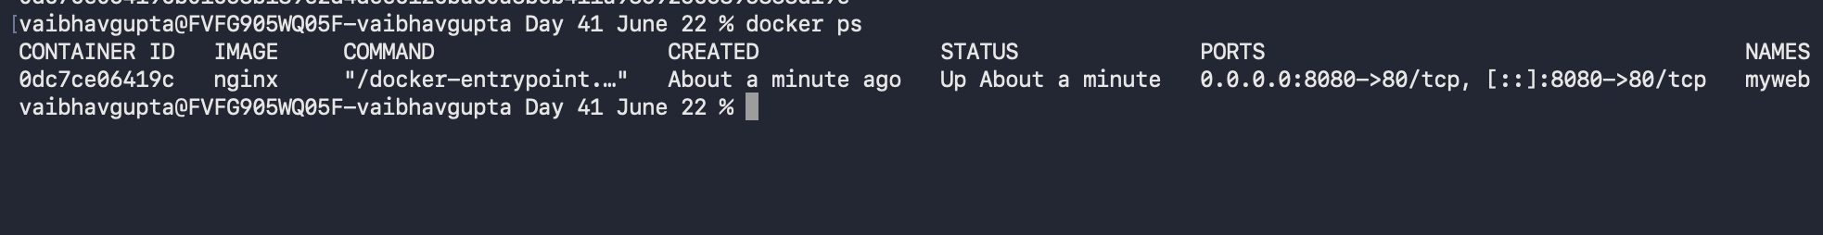

Approach 1 - Create Custom index.html
Command:
Create a local index.html file.
Explanation:
Creates a custom web page.
Expected Output:
________________________________________
Screenshot Placeholder
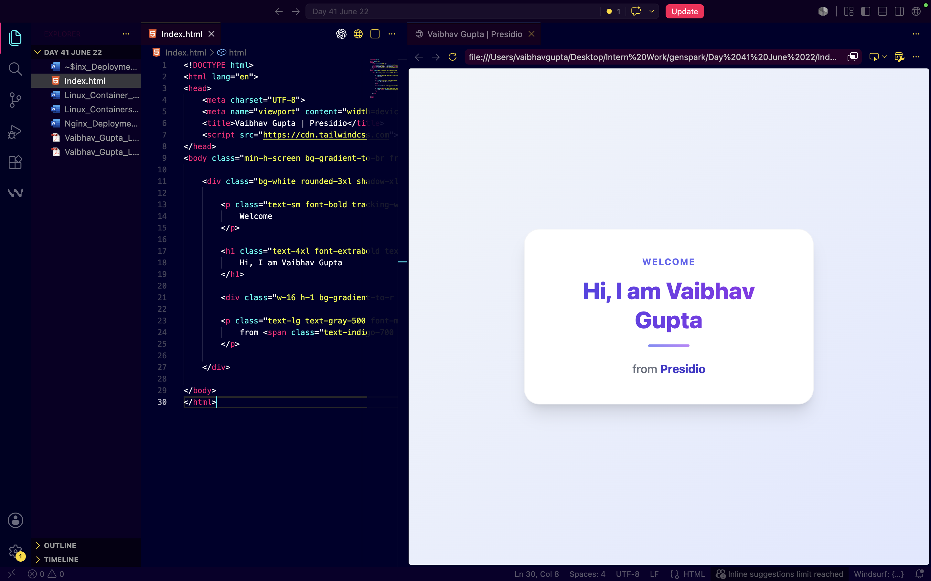

Approach 1 - Copy File
Command:
docker cp index.html myweb:/usr/share/nginx/html/index.html
Explanation:
Copies the local HTML file into the Nginx web root.
Expected Output:
________________________________________
Screenshot Placeholder
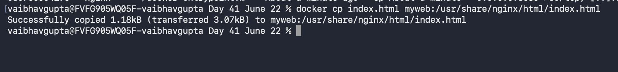

Approach 1 - Verify Website
Command:
Browse to http://localhost:8080
Explanation:
Displays the custom web page.
Expected Output:
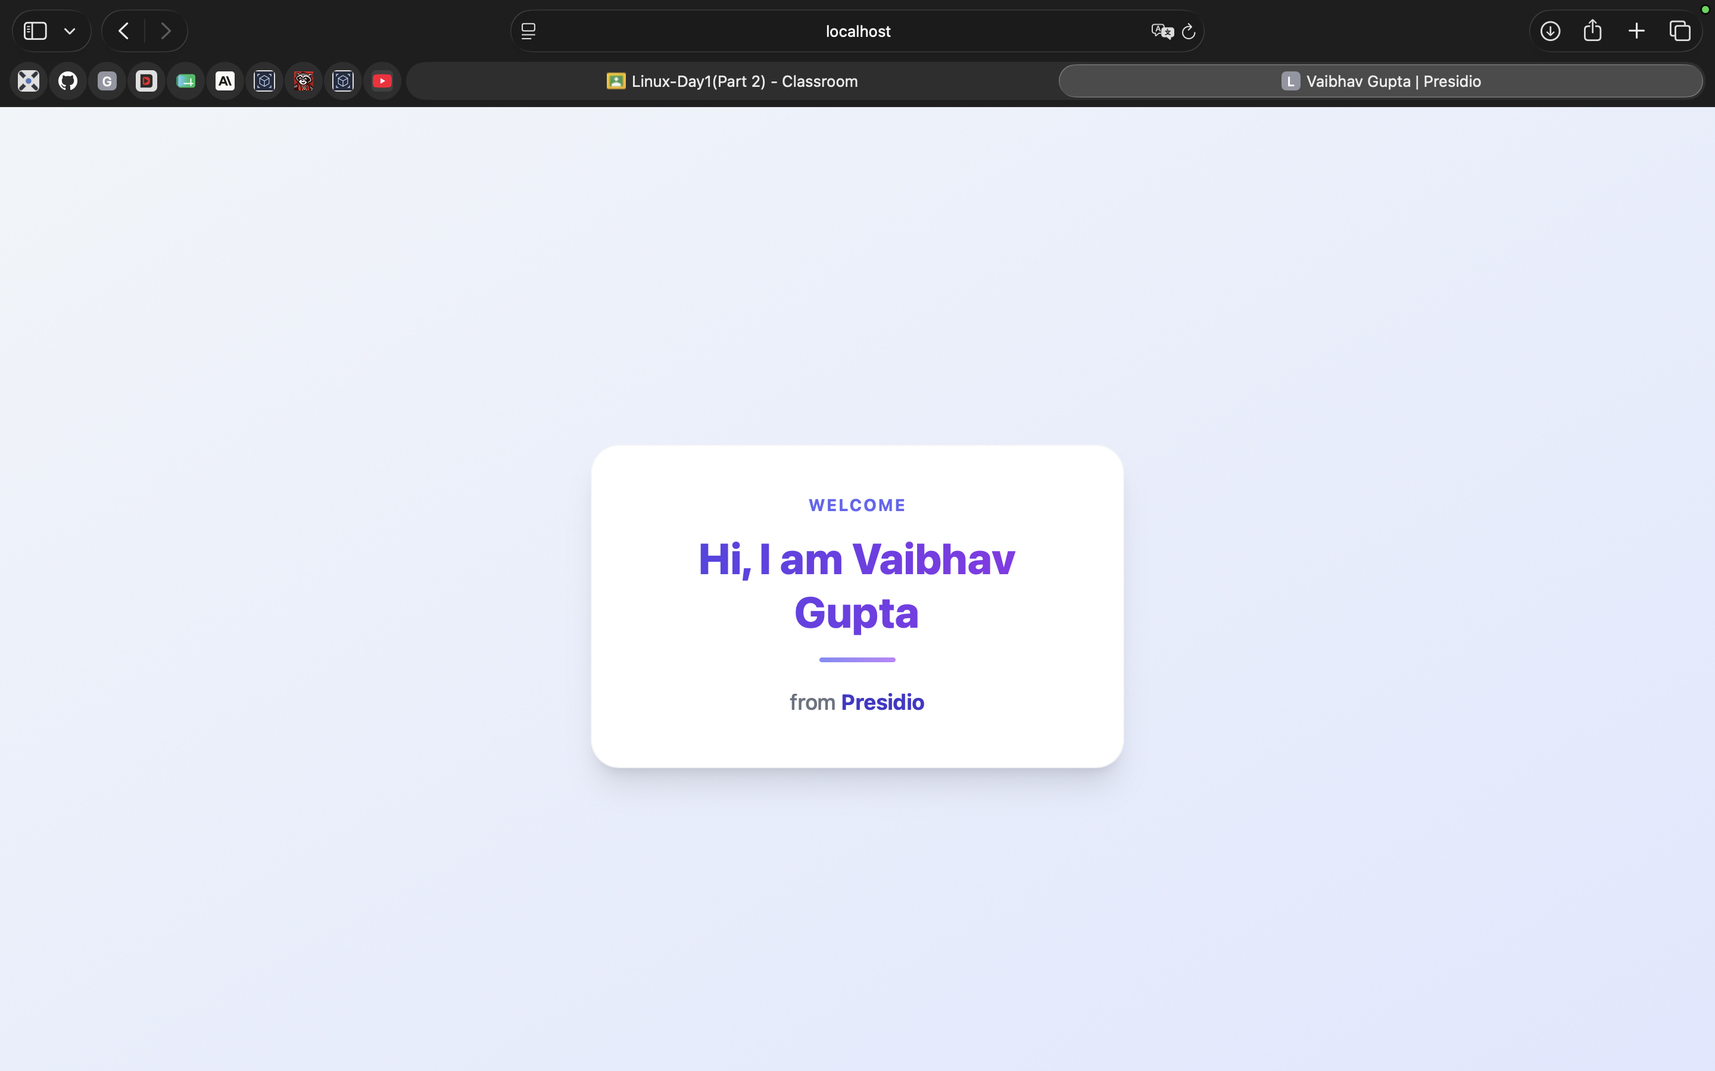

Approach 2 - Pull Ubuntu
Command:
docker pull ubuntu:24.04
Explanation:
Downloads the Ubuntu Linux image.
Expected Output:
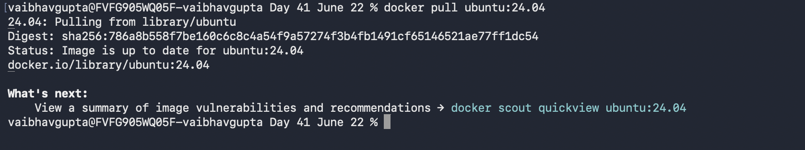

Approach 2 - Start Ubuntu
Command:
docker run -it --name ubuntu-nginx ubuntu:24.04 bash
Explanation:
Starts an interactive Ubuntu container.
Expected Output:
________________________________________
Screenshot Placeholder
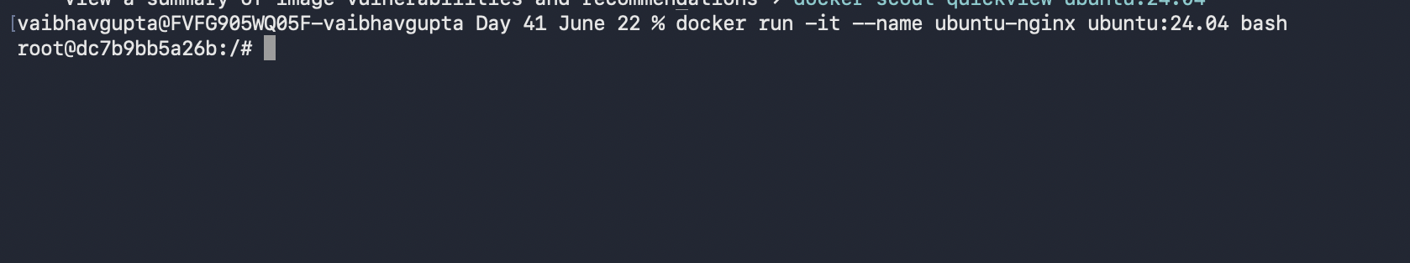

Approach 2 - Update Package Repository
Command:
apt update
Explanation:
Downloads the latest package metadata.
Expected Output:
________________________________________
Screenshot Placeholder
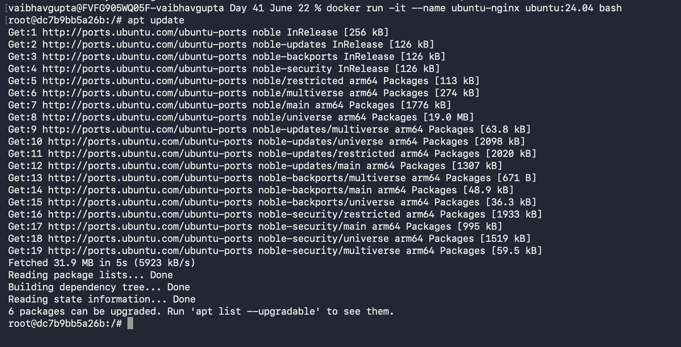

Approach 2 - Install Nginx
Command:
apt install nginx -y
Explanation:
Installs the Nginx web server.
Expected Output:
________________________________________
Screenshot Placeholder
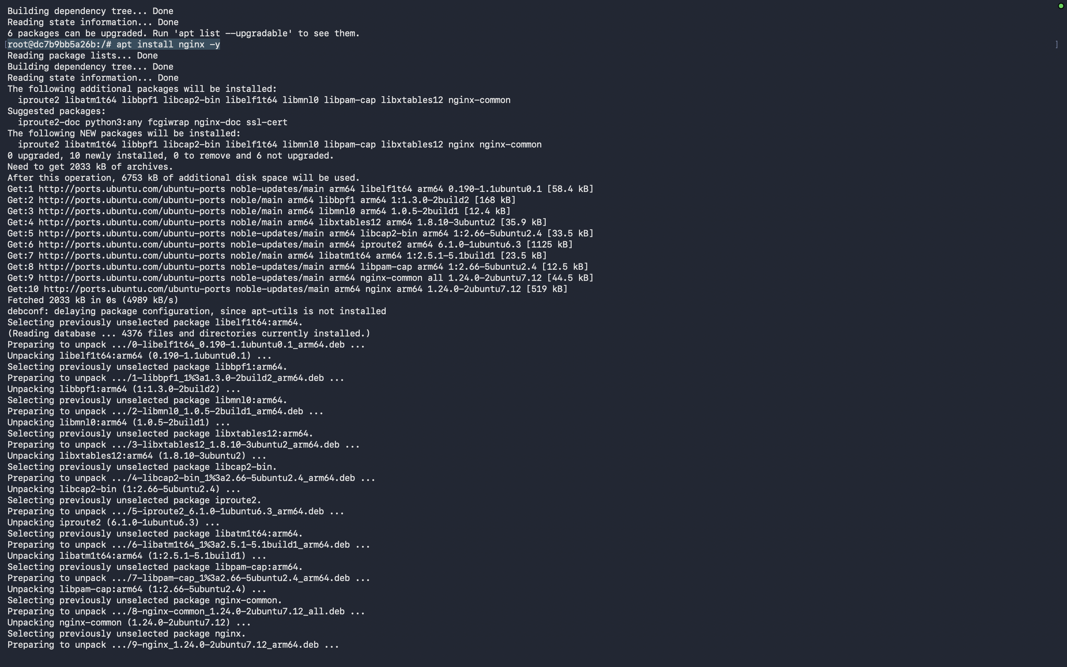
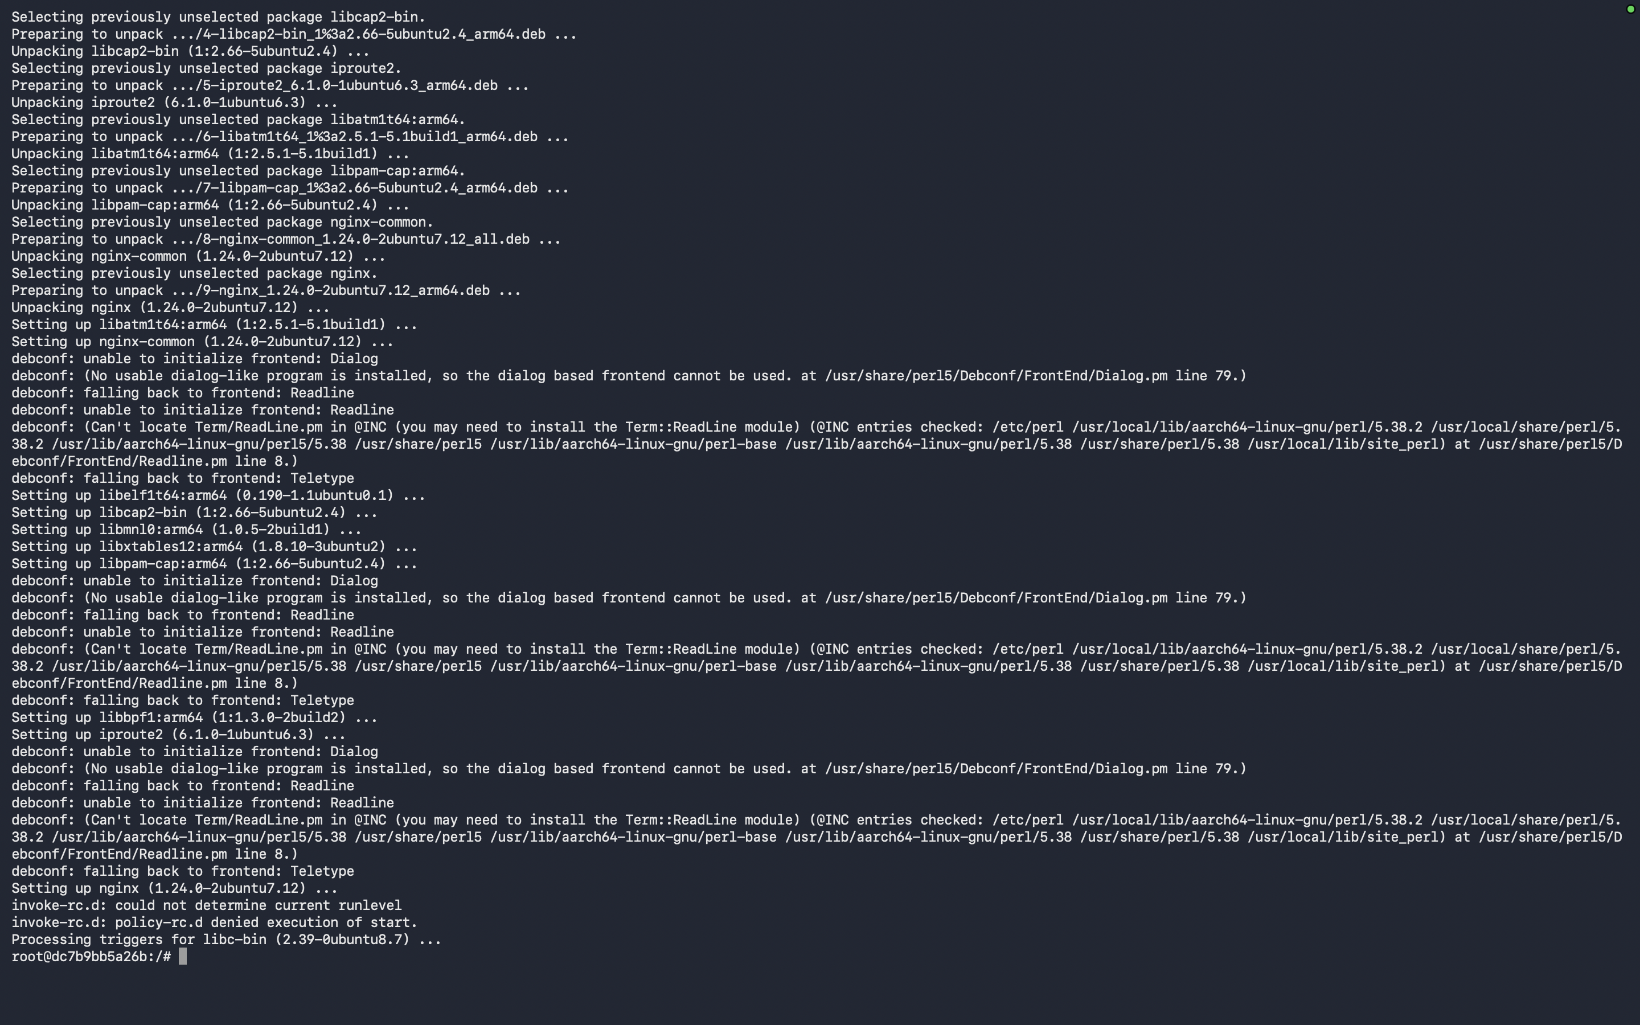

Approach 2 - Verify Nginx
Command:
nginx -v
Explanation:
Displays the installed Nginx version.
Expected Output:
________________________________________
Screenshot Placeholder
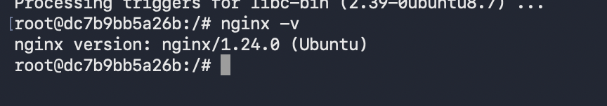

Approach 2 - Create Custom Page
Command:
Edit /var/www/html/index.html
Explanation:
Creates a custom website page.
Expected Output:
________________________________________
Screenshot Placeholder
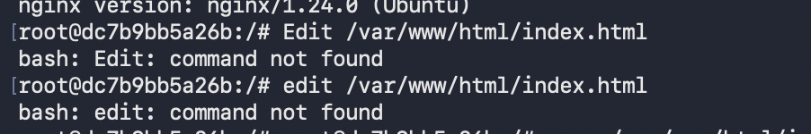
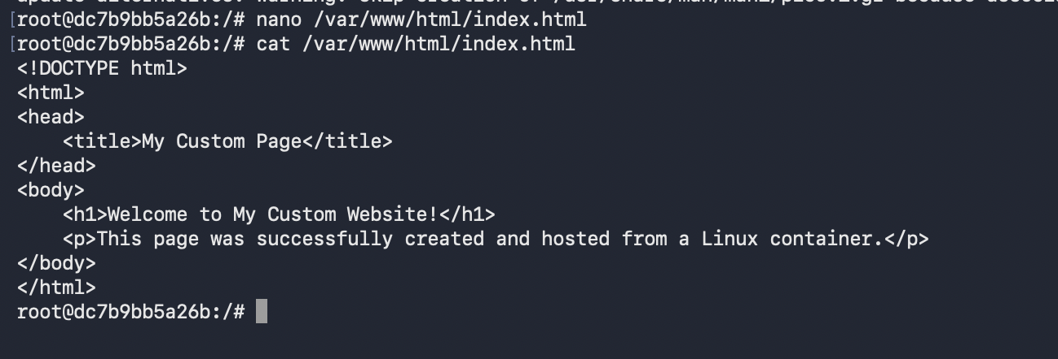

Approach 2 - Start Nginx
Command:
nginx
Explanation:
Starts the Nginx service.
Expected Output:
________________________________________
Screenshot Placeholder
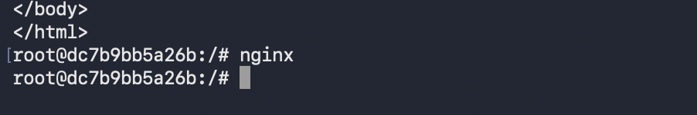

Approach 2 - Verify Locally
Command:
curl localhost
Explanation:
Requests the page from the web server.
Expected Output:
________________________________________
Screenshot Placeholder
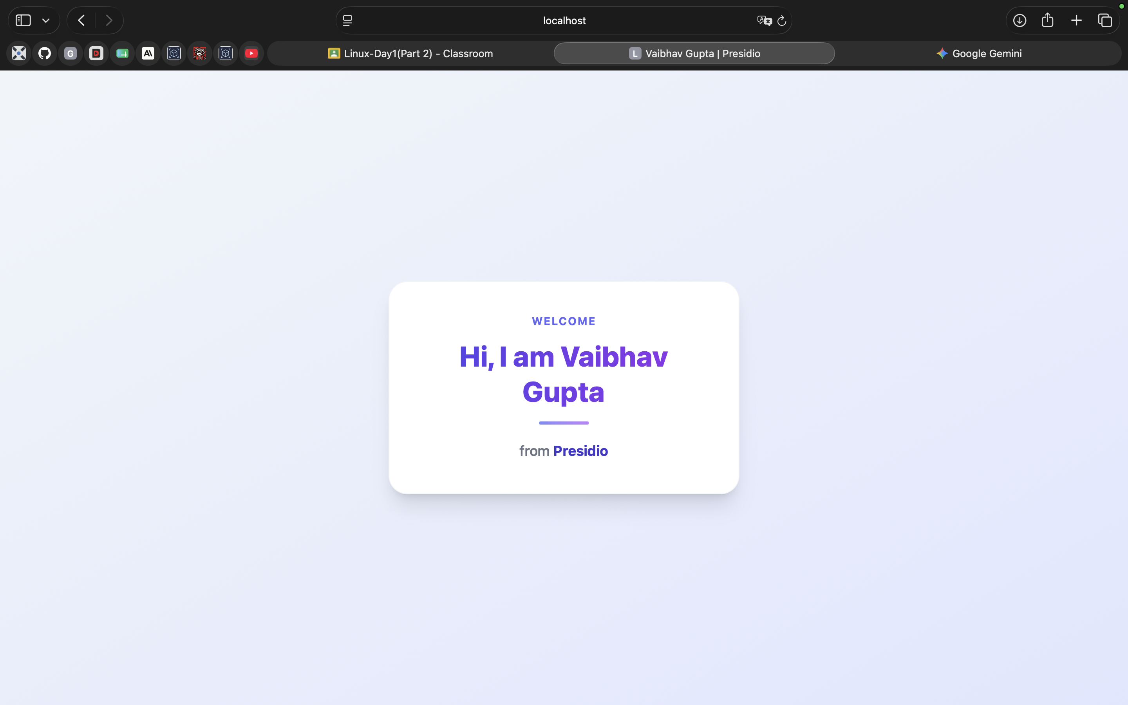

Approach 2 - Commit Container
Command:
docker commit ubuntu-nginx ubuntu-nginx:v1
Explanation:
Saves the modified container as a reusable image.
Expected Output:
________________________________________
Screenshot Placeholder
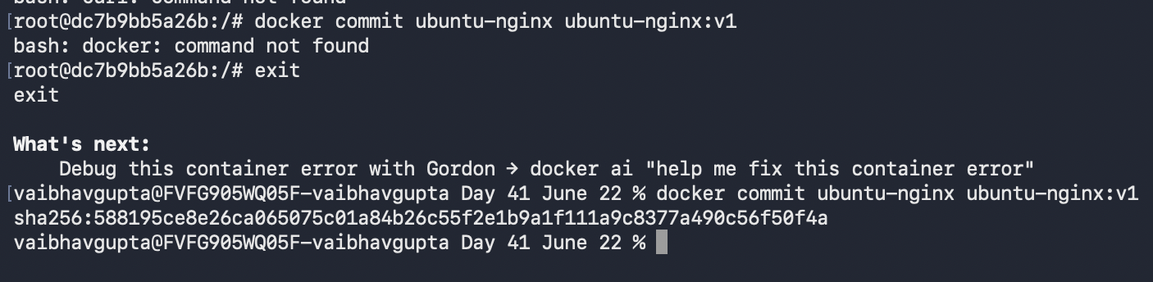

Approach 2 - Run Published Website
Command:
docker run -d --name ubuntu-nginx-web -p 8080:80 ubuntu-nginx:v1 nginx -g 'daemon off;'
Explanation:
Runs the custom image and exposes the website.
Expected Output:
________________________________________
Screenshot Placeholder
